CHAPTER EXAM STOICHEMESTRY BASLT-2A

MULTIPLE CHOICE
- A
- A
- B
- A
- A
- A
- C
- A
- B
- B
- B
- A
- A
- B
- A
- A
- A
- B
- A
- A
- B
- C
- A
- C
- A

PROBLEM SOLVING
1 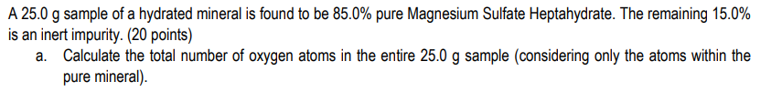
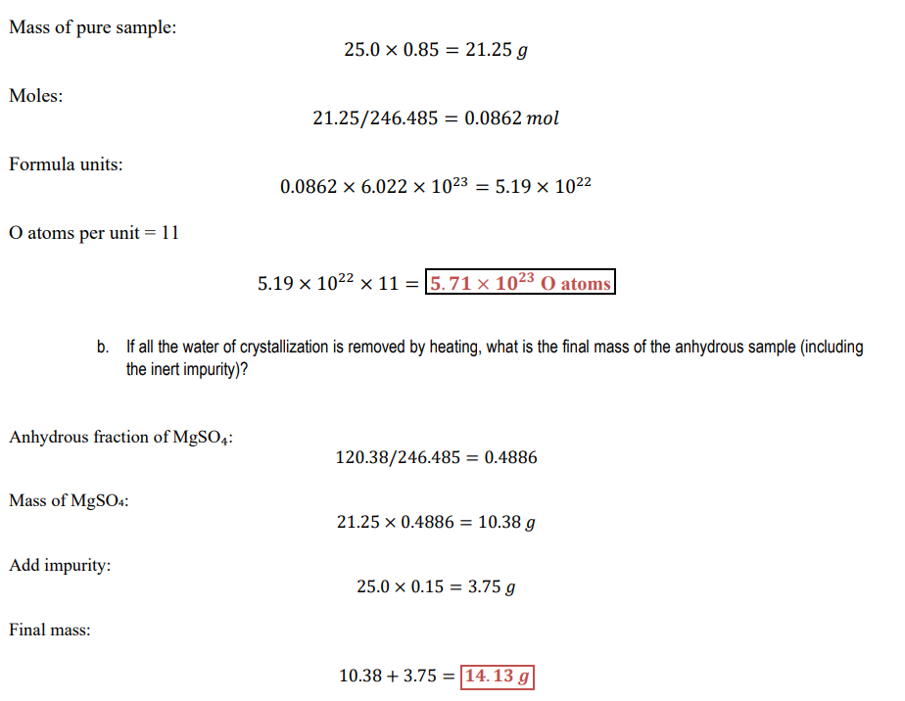


2 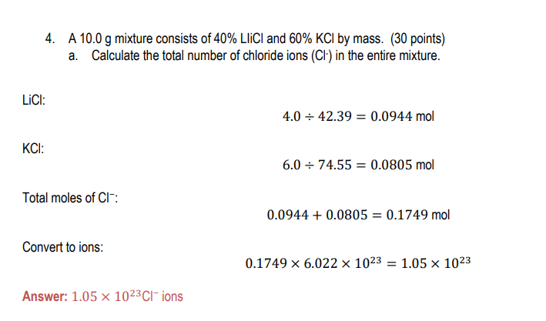
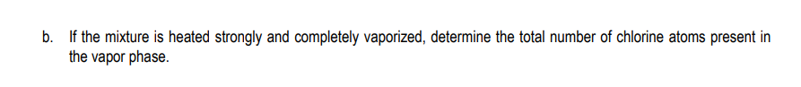
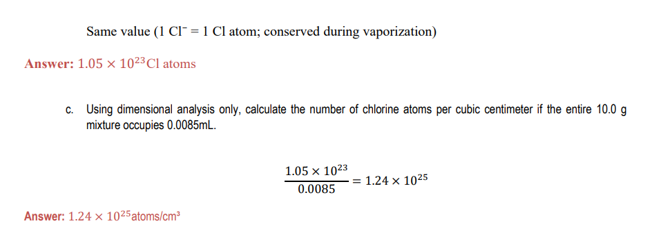

3
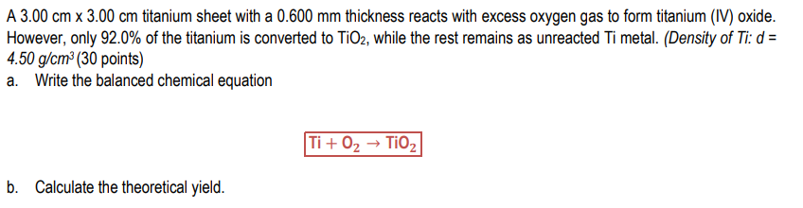
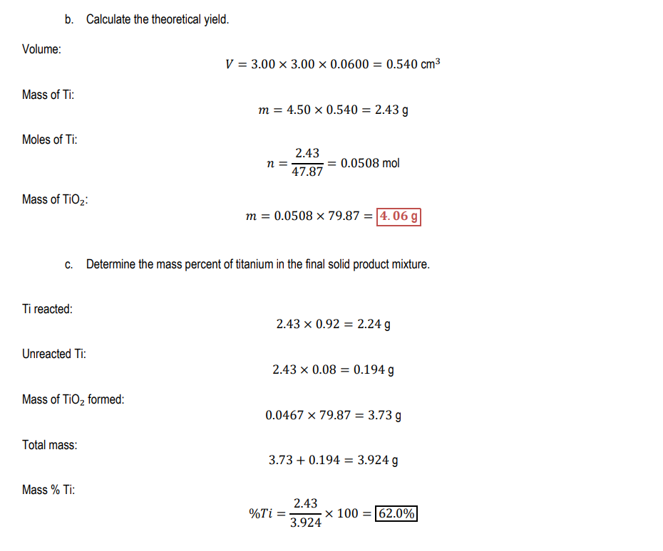


4 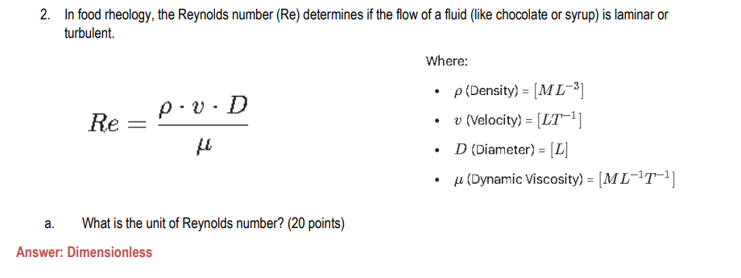

5

